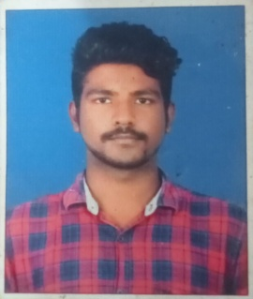**P.V.KISHORE THIRUMALAI**

**7/224, Rajagreegardon, south chathiram, melavalady, Trichy**

**+91 9600468566**

**kishorethirumalai834@gmail.com**

To work as a key player in a challenging and creative environment where I could constantly learn and deliver solutions for the given requirements. To grow and prosper with the company which Encourage new skill acquisition and personal development.

EDUCATION QUALIFICATION:

* B.E (Computer Science) with an aggregate of 80%, Jayaram college of Engineering & technology, Karatampatti, 2024 pass out.
* HSC with an aggregate of 80.2 % INFANT JESUS HR SEC SCHOOL, VINAYAGAPURAM, 2018 pass out.
* SSLC with an aggregate of 51.2% ST. JOSHEP COLLEGE HR SEC SCHOOL, TRICHY,2020 pass out.

SKILLS:

* HTML
* CSS
* JAVA
* PYTHON

PROJECT:

* Secure electronic fund transfere over internet using DES.

PERSONAL DETAILS:

NAME : P.V.KISHORE THIRUMALAI

DATE OF BIRTH : 28-06-2003

GENDER : Male

MARITAL STATUS : Single

NATIONALITY : Indian

LANGUAGE : Tamil and English

STRENGTH:

* Collaboration
* Positive attitude
* Ability to handle tension

DECLARATION:

I hereby declare that the above information is true to the best of my knowledge and belief

Thankyou

Signature

**P.V.KISHORE THIRUMALAI**